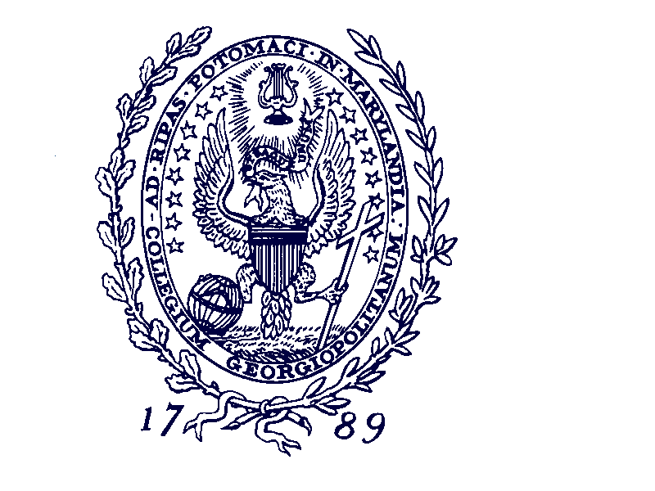

Georgetown University
Center for Applied Legal Studies
Fellowship Announcement
2015-2017 Clinical Teaching Fellowship

Georgetown University's Center for Applied Legal Studies (CALS) announces that it is now accepting applications for its annual fellowship program in clinical legal education. CALS will offer one lawyer a two-year teaching fellowship (July 2015-June 2017), providing a unique opportunity to learn how to teach law in a clinical setting.

At CALS, our two fellows and faculty members work as colleagues, sharing responsibilities for designing and teaching classes, supervising law students in their representation of clients, selecting and grading students, administering the clinic, and all other matters. In addition, the fellow will undertake independent legal scholarship, conducting the research and writing to produce a law review article of publishable quality.

This fellowship is particularly suitable for lawyers who want to embark upon careers in law teaching. Most of our previous fellows are now teaching law or have done so for substantial portions of their careers.

Since 1995, CALS has specialized in asylum claims, for both detained and non-detained applicants, in immigration court removal proceedings. Applicants must have at least two years of practice experience in U.S. immigration and asylum law. The fellow must be a member of a bar at the start of the fellowship period.

The fellow will receive full tuition and fees in the LL.M. program at Georgetown University, and a stipend of at least $53,500 in each of the two years. On successful completion of the requirements, the Fellow will be granted the degree of Master of Laws (Advocacy) with distinction.

Former fellows include Mary Brittingham (1995-97), Andrea Goodman (1996-98), Michele Pistone (1997-99), Rebecca Story (1998-2000), Virgil Wiebe (1999-2001), Anna Marie Gallagher (2000-02), Regina Germain (2001-2003), Dina Francesca Haynes (2002-2004), Diane Uchimiya (2003-2005), Jaya Ramji-Nogales (2004-2006), Denise Gilman (2005-2007), Susan Benesch (2006-2008), Kate Aschenbrenner (2007-2009), Anjum Gupta (2008-2010), Alice Clapman (2009-2011) Geoffrey Heeren (2010-2012), Heidi Altman (2011-2013) and Laila Hlass (2012-2014). The current Fellows are Lindsay M. Harris and Jean C. Han.

The faculty members directing CALS are Andy Schoenholtz and Philip Schrag.

To apply, send a resume, an official or unofficial law school transcript, a writing sample, and a detailed statement of interest (approximately 5 pages). The materials must arrive by December 1, 2014. The statement should address: a) why you are interested in this fellowship; b) what you can contribute to the Clinic; c) your experience with asylum and other immigration cases; d) your professional or career goals for the next five or ten years; e) your reactions to the Clinic's goals and teaching methods as described on its website, http://www.law.georgetown.edu/clinics/cals/index.html; and e) anything else that you consider pertinent. Address your application to Office Manager, Center for Applied Legal Studies, Georgetown Law, 600 New Jersey Avenue, NW, Suite 332, Washington, D.C. 20001, or electronically to calsclinic@law.georgetown.edu.

Georgetown University is an equal opportunity affirmative action employer. We are committed to diversity in the workplace. If you have any questions, call CALS at (202) 662-9565 or email to calsclinic@law.georgetown.edu.

